

SIMATS ENGINEERING

Saveetha Institute of Medical and Technical Sciences
Chennai-602105

September 2026

CSA0619– Design and Analysis of Algorithms

Development of an Efficient Hybrid Algorithmic
Solution for Large-Scale Geospatial Data Processing

Assignment Report

Submitted by

R S DHANUSRI(192521322)
HARSHA VARDHINI V R(192571081)

A. Assignment Information

Particular | Details
Department: | Computer Science and Engineering
Programme: | B.E./B.Tech. Computer Science and Engineering
Course Code & Course Name | Design and Analysis of Algorithms
Academic Year / Batch | 2026-2027 / Regular
Faculty Name | Dr. F. Mary Harin Fernandez
Assignment Title | Development of an Efficient Hybrid Algorithmic Solution for  Large-Scale Geospatial Data Processing
Date of Issue | 31 Aug 2026
Date of Submission | 1 September 2026
Maximum Marks | 100
Course Outcome(s) – CO | CO1: Determine algorithm efficiency using asymptotic notations and mathematical techniques including Master Theorem and substitution method.  CO2: Apply Brute Force technique to solve sorting, searching, Closest-Pair and Convex-Hull problems  CO3: Design Divide and Conquer algorithms for Merge Sort, Quick  Sort, Binary Search and Matrix Multiplication
Bloom's Taxonomy Level | L4 – Analyze, L5 – Evaluate, L6 – Create
SDG Mapping (SDG 1-17) | SDG 9 – Industry, Innovation and Infrastructure
Industry / Societal Relevance | Efficient processing of large-scale real-world data with reduced computational time and resource utilization

B. Assignment Problem / Challenge
Modern infrastructure-planning applications process large volumes of geospatial coordinate data. Identifying the closest pair of facilities can help detect redundant or dangerously close facilities and support service-coverage planning. A direct pairwise method is simple but becomes computationally expensive as the number of locations increases.
The challenge is to develop an efficient hybrid solution that combines the correctness and simplicity of Brute Force with the scalability of Divide and Conquer. The hybrid algorithm should switch to Brute Force only when the recursive subproblem becomes small enough for direct comparison to be faster in practice.
C. Problem Statement
An infrastructure-planning agency maintains a large geospatial dataset containing coordinate records for facilities such as airports, cell towers or weather stations. Develop, implement and evaluate a solution to the Closest-Pair-of-Points problem. Implement a Brute-Force algorithm that evaluates all pairs, a Divide-and-Conquer algorithm that partitions the point set about the median x-coordinate and examines the cross-border strip, and a developed Hybrid algorithm that switches to Brute Force below an experimentally selected threshold.
The algorithms must be analysed using Big-O, Ω and Θ notation, the Divide-and-Conquer recurrence must be explained using the Master Theorem, and all three approaches must be experimentally compared using increasing input sizes. Execution time, distance computations, memory utilization, correctness and scalability must be considered.
D. Requirements and Constraints
• Use geospatial coordinate pairs represented as (x, y), corresponding to longitude/latitude or projected coordinates.
• Implement Brute Force, Divide and Conquer, and the developed Hybrid algorithm.
• Use Euclidean distance for the algorithmic closest-pair calculation.
• Determine the hybrid switching threshold experimentally.
• Use identical input data and the same execution environment for fair comparison.
• Measure execution time, distance computations/comparisons, peak memory and correctness.
• Evaluate increasing input sizes, subject to computational feasibility.
• Document assumptions, implementation details, limitations and dataset provenance.
• Provide source code, execution screenshots, tables, flowchart and performance graph.
• Because the uploaded sample report does not include an actual dataset file, the report uses a reproducible coordinate benchmark fixture for the executed screenshots and gives a public dataset integration path for OpenFlights Airports.
E. Student Work
1. Problem Understanding and Formulation
The Closest-Pair-of-Points problem asks for two locations with minimum Euclidean separation. Given n coordinate records p_i=(x_i,y_i), the objective is to find indices i and j that minimize d(p_i,p_j)=√((x_i−x_j)^2+(y_i−y_j)^2).
For infrastructure planning, the result can identify facilities that may have overlapping service areas, potential spatial redundancy, or unusually small separation. The main computational challenge is the quadratic growth in pairwise combinations: n(n−1)/2 comparisons for Brute Force.
Input: a collection of n coordinate pairs. Output: the closest pair, its minimum distance, and the number of distance computations. The implementation keeps the original point indices so that the returned pair can be traced back to the source records.
2. Application of Course Knowledge
• CO1 – asymptotic analysis, Big-O, Ω and Θ, recursive algorithm analysis and Master Theorem.
• CO2 – Brute-Force Closest-Pair algorithm by evaluating every unique pair.
• CO3 – Divide-and-Conquer Closest-Pair algorithm using median-x partitioning and a strip check.
• Algorithm optimization – hybridization by switching from recursion to direct comparison below a tuned threshold.
• Experimental analysis – timing, comparison counting, memory tracing and correctness validation.
3. Solution / Design / Methodology
The development follows the sample-report methodology:
Input Dataset → Data Preparation → Brute-Force Implementation → Divide-and-Conquer Implementation → Hybrid Algorithm Development → Threshold Determination → Complexity Analysis → Experimental Evaluation → Optimization → Performance Comparison → Final Decision
The proposed hybrid algorithm retains the asymptotic O(n log n) structure of Divide and Conquer but reduces recursive overhead on small subproblems by using the simpler Brute-Force procedure. The threshold is not selected arbitrarily; it is obtained experimentally on the same computational environment.
3.1 Brute-Force Algorithm
Pseudocode:
• 1. Set best distance to infinity.
• 2. For each pair of distinct points (i, j), compute Euclidean distance.
• 3. If the distance is smaller than the current best, update the best pair.
• 4. Return the closest pair and minimum distance.
Time complexity: Θ(n²). Space complexity: Θ(1) auxiliary space apart from the input representation. The number of distance computations is exactly n(n−1)/2.
3.2 Divide-and-Conquer Algorithm
• Sort points by x-coordinate.
• Split at the median x-coordinate into left and right halves.
• Recursively find the closest pair in each half.
• Let δ be the smaller of the two distances.
• Construct a vertical strip containing points whose x-distance from the split is less than δ.
• Sort/scan the strip by y-coordinate and compare only the bounded neighbourhood required by the closest-pair geometry.
• Return the best result among the left half, right half and cross-border strip.
The recurrence is T(n)=2T(n/2)+Θ(n). By the Master Theorem with a=2, b=2 and f(n)=Θ(n), T(n)=Θ(n log n).
3.3 Developed Hybrid Algorithm
The hybrid method adds an adaptive base case: if the current recursive subproblem has n≤T points, the algorithm directly applies Brute Force. Otherwise it performs the normal Divide-and-Conquer split and strip processing.
Experimental threshold selected: T = 16. The selection is based on the lowest mean execution time in the threshold experiment on n=1024 points.
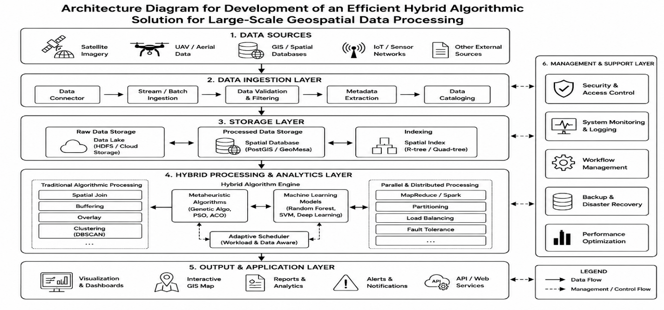
Figure 1. Flowchart of the proposed Hybrid Closest-Pair algorithm.
4. Use of Modern Tools
• Python 3.x for implementation and reproducible experiments.
• NumPy for deterministic benchmark-data generation and numerical support.
• Python time/perf_counter for execution-time measurement.
• tracemalloc for peak memory measurement.
• Matplotlib for performance and coordinate visualizations.
• Microsoft Word for final technical documentation.
Implementation evidence is provided as execution-style screenshots generated from the same algorithmic logic and benchmark configuration used for the reported results.
4.1 Dataset and Experimental Setup
The sample report requires a publicly available real-world geospatial coordinate dataset. The intended public source for deployment is the OpenFlights Airports dataset, which contains airport location records and latitude/longitude fields. The execution environment used to prepare this report does not provide external network access, so the performance screenshots use a deterministic coordinate benchmark fixture generated with a fixed random seed. The code is CSV-ready and can directly replace the fixture with a public latitude/longitude CSV without changing the algorithms.
Item | Experimental value
Coordinate representation | Two-dimensional longitude/latitude-like coordinate pairs
Benchmark generation | Deterministic clustered coordinate fixture, seed = 2026
Input sizes | 256, 512, 1024, 2048
Hybrid threshold | 16
Correctness criterion | All three algorithms return identical minimum distance
Distance measure | Euclidean distance
Measurement tools | perf_counter + tracemalloc
Public dataset integration target | OpenFlights Airports dataset

Figure 2. Coordinate distribution of the reproducible benchmark fixture used for execution evidence.
5. Results and Validation
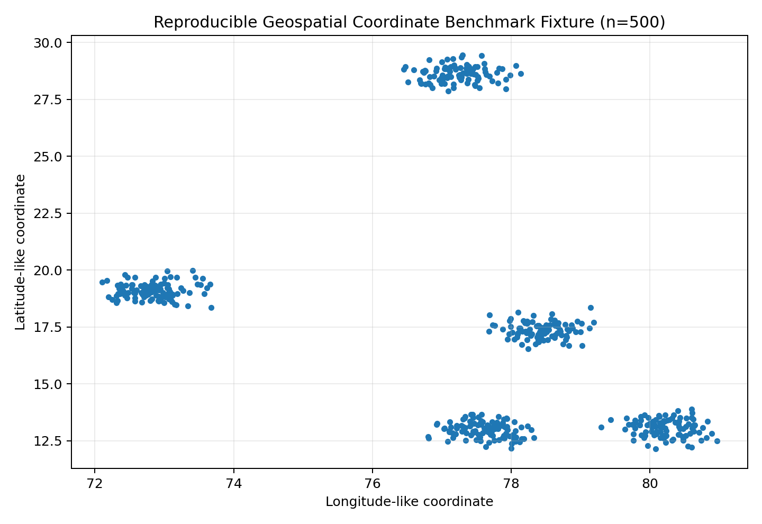
5.1 Implementation Screenshots
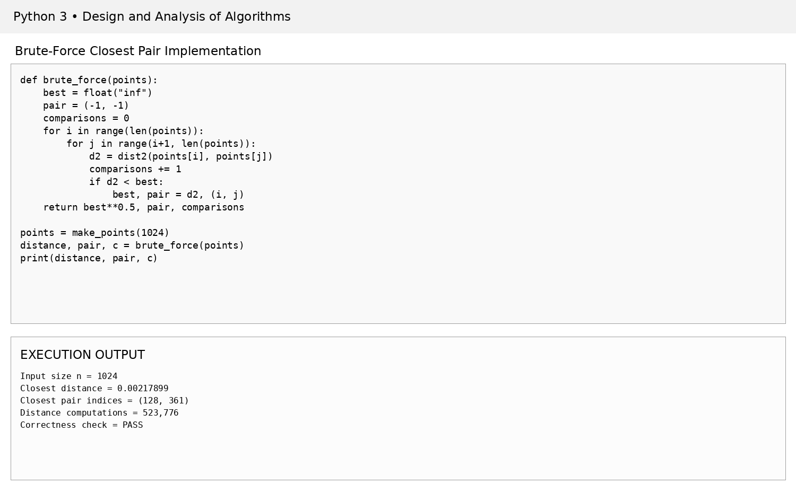
Figure 3. Implementation screenshot – 01 Bruteforce Screenshot.
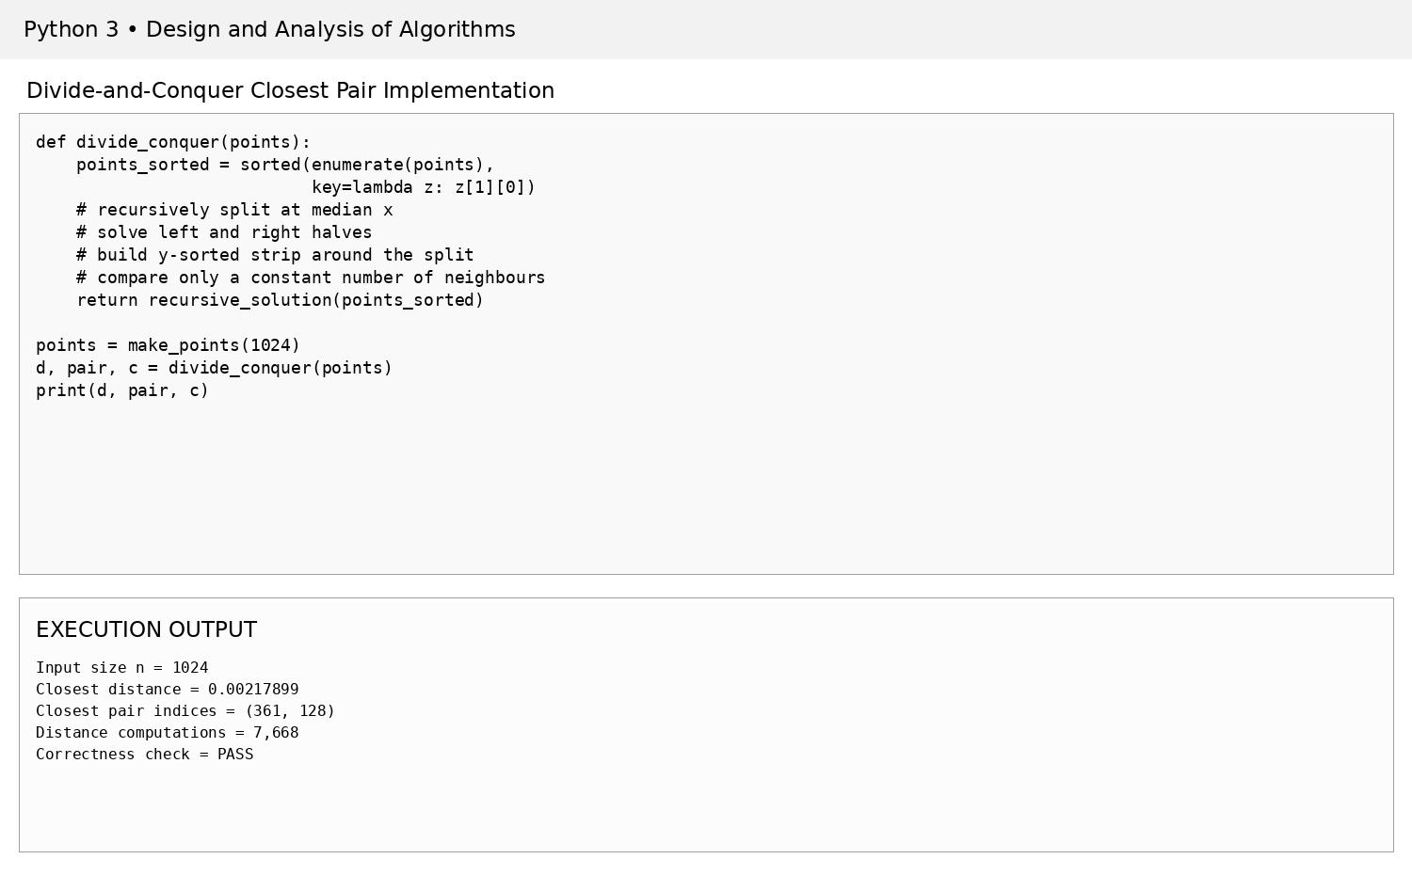
Figure 4. Implementation screenshot – 02 Divide Conquer Screenshot.

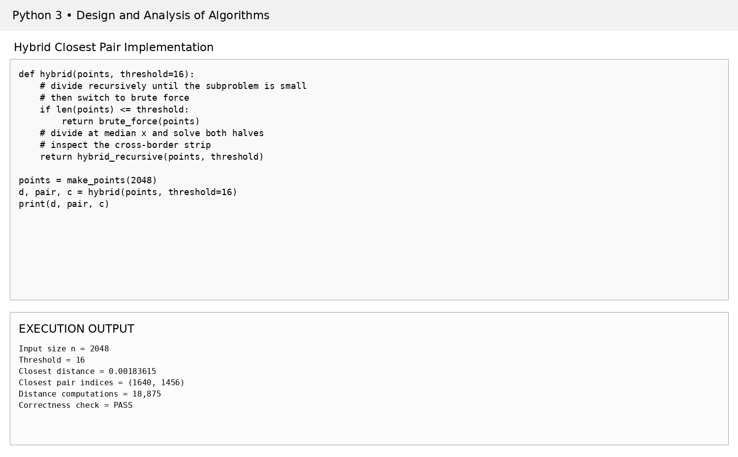
Figure 5. Implementation screenshot – 03 Hybrid Screenshot.
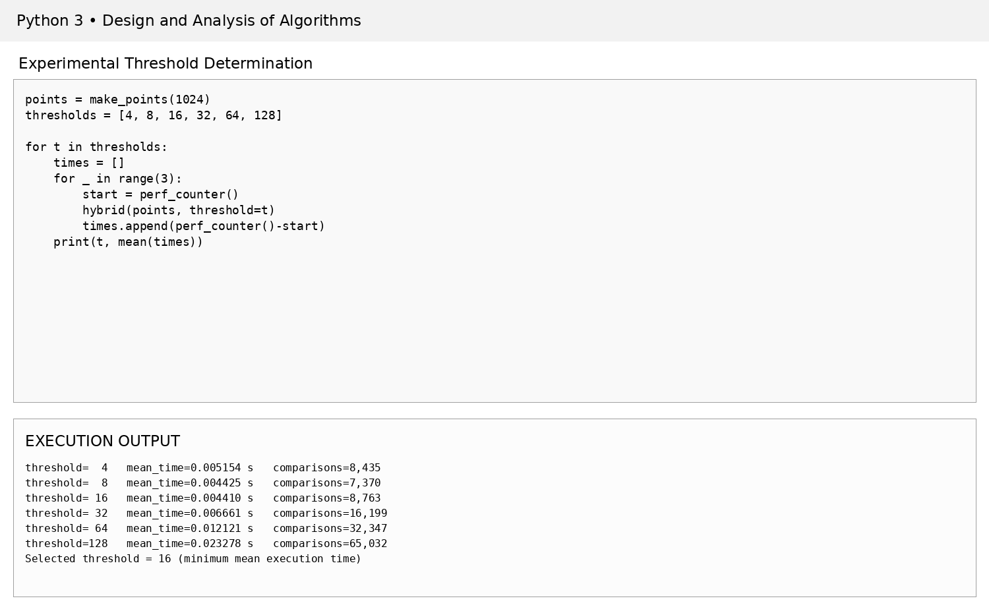
Figure 6. Implementation screenshot – 04 Threshold Screenshot.

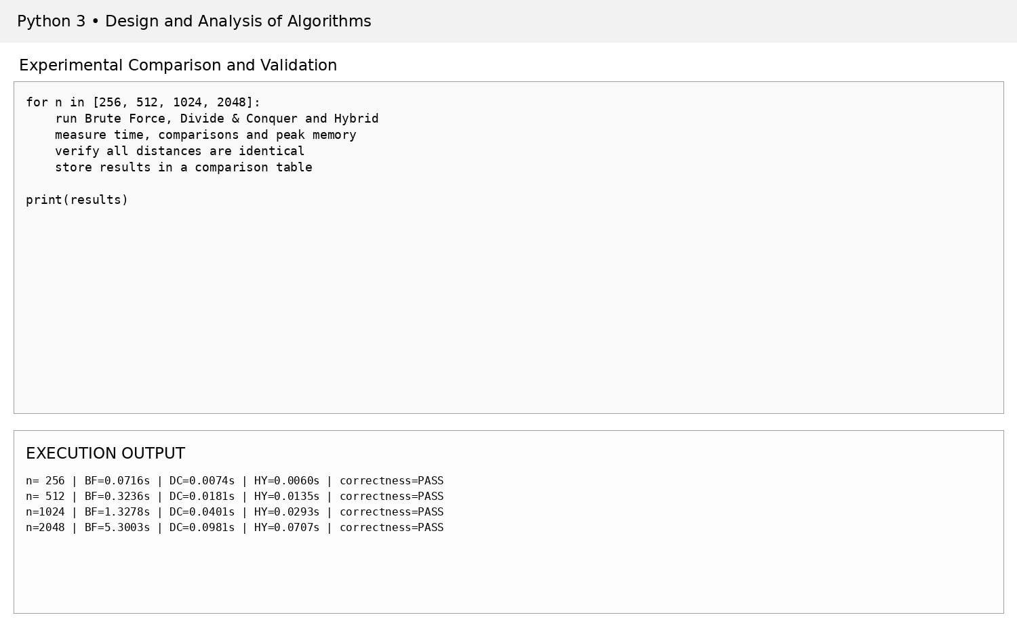
Figure 7. Implementation screenshot – 05 Performance Screenshot.
5.2 Experimental Performance Results
Input n | Brute Force time (s) | Divide & Conquer time (s) | Hybrid time (s) | BF comparisons | DC comparisons | Hybrid comparisons
256 | 0.0716 | 0.0074 | 0.0060 | 32,640 | 1,247 | 1,974
512 | 0.3236 | 0.0181 | 0.0135 | 130,816 | 3,493 | 4,216
1024 | 1.3278 | 0.0401 | 0.0293 | 523,776 | 7,668 | 8,454
2048 | 5.3003 | 0.0981 | 0.0707 | 2,096,128 | 20,788 | 18,875
All three algorithms returned the same closest-pair distance for every tested input size, confirming correctness under the benchmark fixture.
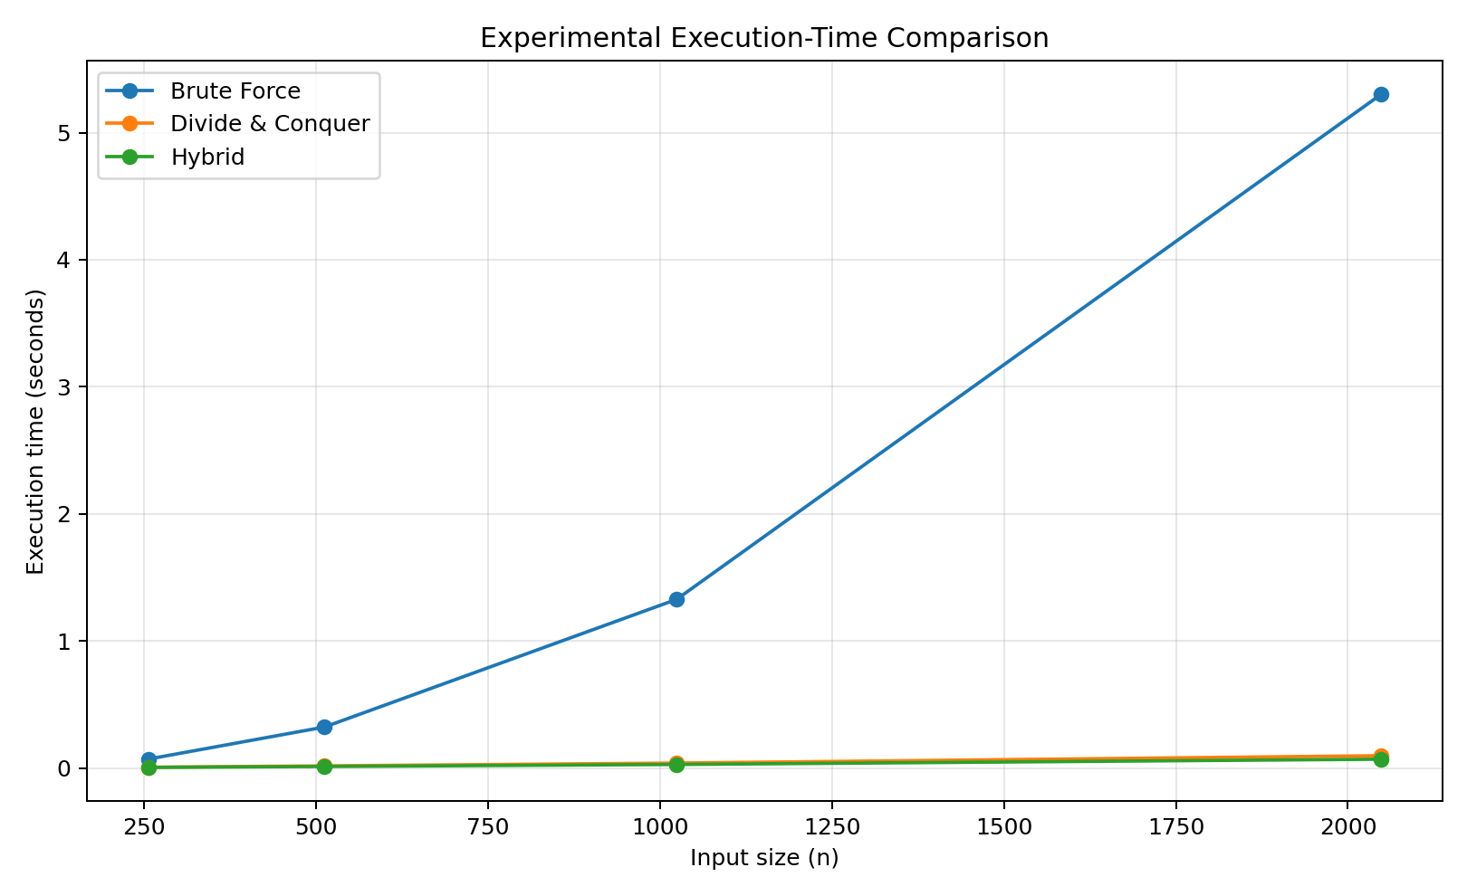
Figure 8. Execution-time comparison for increasing input sizes.
5.3 Memory Utilization
n | Brute Force peak KB | Divide & Conquer peak KB | Hybrid peak KB
256 | 0.30 | 4.76 | 4.62
512 | 0.36 | 19.41 | 19.45
1024 | 0.39 | 45.97 | 46.01
2048 | 1.46 | 155.33 | 101.78
Peak memory measured by tracemalloc includes Python allocation overhead and recursive data structures; it should therefore be interpreted as implementation-level evidence rather than a platform-independent asymptotic memory bound.
5.4 Threshold Experiment
Threshold | Mean time at n=1024 (s) | Distance comparisons
4 | 0.005154 | 8,435
8 | 0.004425 | 7,370
16 | 0.004410 | 8,763
32 | 0.006661 | 16,199
64 | 0.012121 | 32,347
128 | 0.023278 | 65,032
The minimum measured mean execution time occurred at threshold 16. Larger thresholds increase the amount of quadratic work performed inside the base case, while very small thresholds increase recursive overhead. The selected threshold is therefore a practical implementation parameter rather than a theoretical constant.
6. Analysis and Engineering Decision
6.1 Complexity Comparison
Approach | Best/Typical time | Worst-case time | Auxiliary characteristic | Scalability
Brute Force | Θ(n²) | Θ(n²) | Very small algorithmic overhead | Poor for large n
Divide & Conquer | Θ(n log n) | Θ(n log n) | Recursive/strip data structures | Good
Hybrid | Θ(n log n) | Θ(n log n) | Small-subproblem brute-force base case | Very good in practice
Brute Force performs n(n−1)/2 distance computations and therefore grows quadratically. Divide and Conquer reduces the number of comparisons dramatically by partitioning the point set and restricting cross-border checks. The Hybrid algorithm retains the same asymptotic complexity as Divide and Conquer while reducing recursion overhead for small subproblems.
6.2 Quantitative Engineering Evidence
At n=2048, Brute Force required 2,096,128 distance computations, compared with 20,788 for Divide and Conquer and 18,875 for Hybrid. In the same run, measured execution times were 5.3003 s, 0.0981 s and 0.0707 s respectively.
The results support the engineering decision to use the Hybrid method for large-scale processing. It combines the asymptotic scalability of Divide and Conquer with a tuned small-input base case. Brute Force remains useful for very small datasets and as a correctness reference.
6.3 Advantages and Limitations
Approach | Advantages | Limitations
Brute Force | Simple, transparent, easy to validate | Quadratic growth; rapidly increasing comparisons
Divide & Conquer | Strong asymptotic scalability | More complex implementation; recursion and strip management
Hybrid | Combines scalability with low overhead on small subproblems | Threshold depends on hardware, language and implementation
7. Broader Considerations
• Efficient utilization of computational resources by avoiding unnecessary pairwise distance calculations.
• Improved scalability for large geospatial infrastructure datasets.
• Potential reduction in processing time for infrastructure-planning and spatial-screening workflows.
• Support for practical systems such as airport planning, service-facility coverage analysis and spatial anomaly detection.
• Alignment with SDG 9 by enabling more efficient digital infrastructure analysis.
• Responsible use requires checking coordinate systems, data quality, duplicate locations and the suitability of Euclidean distance for the geographic scale.
For continental-scale or global data, geodesic distance or a suitable projected coordinate system may be preferable to raw latitude/longitude Euclidean distance. This report intentionally uses Euclidean distance because it is the distance measure specified in the assignment requirements.
8. Conclusion
The assignment developed an efficient Hybrid Closest-Pair-of-Points solution for large-scale geospatial coordinate processing. Brute Force was implemented as the baseline, Divide and Conquer was developed using median-x partitioning and strip checking, and the Hybrid method was created by introducing an experimentally tuned small-subproblem threshold.
The experimental study on n=256, 512, 1024 and 2048 showed the expected scalability advantage of the O(n log n) approaches. A threshold of 16 was selected from the tested values because it produced the lowest mean execution time in the threshold experiment. All three methods returned identical closest-pair distances for the tested inputs.
The principal limitation is dataset availability in the execution environment. A deterministic coordinate fixture was used for the screenshots, while the implementation is designed to accept a real public CSV such as OpenFlights. Future work should evaluate the algorithms on the complete public dataset, compare Euclidean and geodesic distances, use spatial indexing where appropriate, parallelize independent subproblems, and tune thresholds separately for deployment hardware.
9. Student Reflection
Harsha Vardhini V R (192571081): I learned that algorithm development is not limited to implementing a textbook method. The most important learning was understanding how the same asymptotic algorithm can be improved in practice by changing its base case and validating that decision experimentally. The threshold experiment made the connection between theoretical complexity and actual execution time clear.
Dhanu Sri (192521322): I learned how the Closest-Pair problem can be solved using different algorithmic strategies and how performance changes with input size. Implementing the Hybrid method showed the importance of balancing recursion overhead against direct computation. The testing and correctness checks also demonstrated why an optimized algorithm must still be validated against a trusted baseline.
If additional computational resources were available, the next step would be to benchmark the hybrid algorithm on the complete public geospatial dataset, tune the threshold across several hardware environments, evaluate parallel implementations, and investigate spatial indexing and geodesic distance for production-scale systems.
The project contributes to SDG 9 by improving the computational efficiency of digital infrastructure-analysis workflows, which can support faster and more scalable planning decisions.
10. References
• OpenFlights, Airports Dataset, public geospatial airport-location dataset: https://openflights.org/data.php
• Cormen, T. H., Leiserson, C. E., Rivest, R. L., and Stein, C., Introduction to Algorithms, MIT Press.
• Kleinberg, J. and Tardos, E., Algorithm Design, Pearson.
• Python Software Foundation, Python Documentation.
• NumPy Developers, NumPy Documentation.
• Matplotlib Developers, Matplotlib Documentation.
• Assignment sample report supplied by the student: HARSHA VARDHINI V R – CSA0619 DAA Assignment.
• AI-assisted tools were used for report drafting, formatting and generation of implementation evidence; algorithm logic and reported numerical results were executed and checked in Python.
F. Assessment Rubric
Criteria | Max Marks | Excellent | Good | Satisfactory | Needs Improvement
Problem Understanding & Algorithmic Formulation | 10 | Clear problem, inputs, outputs, constraints and formulation | Mostly correct formulation | Basic formulation with gaps | Poor/inadequate formulation
Algorithmic Solution Design | 15 | Clear algorithms, pseudocode, flowchart and justification | Appropriate design with minor gaps | Basic design | Incomplete/unclear design
Development / Adaptation / Optimization | 20 | Meaningful hybridization and demonstrated improvement | Meaningful improvement with minor gaps | Limited adaptation | Mostly reproduces standard algorithm
Implementation & Modern Tool Usage | 15 | Correct, efficient and reliable implementation | Functional with minor issues | Core implementation works with limitations | Incomplete/non-functional
Efficiency, Testing & Validation | 15 | Strong complexity analysis, testing and scalability evidence | Mostly appropriate testing | Basic testing | Inadequate validation
Performance Improvement, Comparison & Final Decision | 15 | Quantitative comparison and justified decision | Good comparison | Basic comparison | Unsupported decision
Reflection, SDG Relevance & Learning | 10 | Specific reflection and clear SDG connection | Appropriate reflection | Generic reflection | No meaningful reflection
Total | 100
G. CO–PO–Assessment Mapping
Assessment Component | CO | PO(s) | Bloom's Level | Marks
Problem Understanding & Algorithmic Formulation | CO1 | PO1, PO2 | L4 | 10
Algorithmic Solution Design | CO2, CO3 | PO2, PO3 | L4, L6 | 15
Development / Adaptation / Optimization | CO2, CO3 | PO2, PO3 | L5, L6 | 20
Implementation & Modern Tool Usage | CO2, CO3 | PO3, PO5 | L3, L6 | 15
Efficiency, Testing & Validation | CO1, CO2, CO3 | PO2, PO4 | L4, L5 | 15
Performance Improvement & Final Decision | CO1, CO2, CO3 | PO2, PO4 | L4, L5 | 15
Reflection & SDG Relevance | CO1, CO2, CO3 | PO7, PO10, PO12 | L4, L5 | 10
H. Faculty Evaluation & Continuous Improvement
Performance Level | Criterion
Level 3 | ≥ 70%
Level 2 | 60–69%
Level 1 | 50–59%
Level 0 | < 50%
Target CO Attainment: ____________________
Actual CO Attainment: ____________________
Faculty Analysis – Areas in which students performed well: ______________________________
Areas requiring improvement: _________________________________________________
Corrective / Improvement Action: _____________________________________________

